

# ENGLISH

Children will be focussing their writing this term around our Frozen Kingdom topic. This will include reading a range of recounts from the sinking of the Titanic and writing an explanation text. Other non-fiction writing will include a fact file of an animal and leaflet/poster.

Finally, haikus will form our poetry focus for this term.

# MATHS

In accordance with the National Curriculum we will focus our attention on: fractions, decimals and percentages. Shape, space and measure will also be taught.

The children will become masters at problem solving using a variety of mathematical reasoning skills. Our weekly arithmetic tests will continue as well.

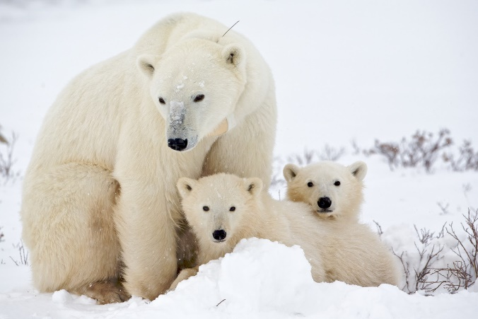







**MUSIC:**

We will be singing a range of songs in readiness for a performance at the Derngate in March, more information to follow!

**RE:** The children will be exploring the religion of Sikhsm.

# FRENCH

We will continue our programme of language games, songs and stories to develop and extend basic language skills.

**PERSONAL WELL BEING**

**JIGSAW**: We will be looking at goals and dreams, enabling children to build positive relationships with peers and build confidence in new situations.

**GAMES / PE:** Games will be Tag Rugby. Circuits will be taught during our P.E sessions.

**YEAR 6**

**CURRICULUM**

**MAP SPRING**

Frozen Kingdom

**HOME LEARNING:**

* Homework/Learning Logs come home every Wednesdayand are expected to be returned on Monday (CGP revision books will be used as part of the homework).
* Reading and times table practice will be expected weekly.
* Spellings will also be set on a weekly basis according to individual spelling phases, these will be tested on a Friday.
* If you have any resources or skills that we could utilise for this term’s topic, then please let us know!

**GEOGRAPHY AND HISTORY:**

**HISTORY:**The children will be learning about emigration and exploration in the early 1900s. Including looking at Robert Falcon Scott.

**GEOGRAPHY:**

# We will use maps and atlases to locate information about the polar regions (Arctic and Antarctica) and other countries with cold climates.