

CHILDREN’S
ATTENDANCE & TERM TIME LEAVE POLICY

September 2025

SECTION 1: POLICY

The law states that a child is required to attend regularly at the school where they are a registered pupil.

Regular school attendance and punctuality are extremely important. Valuable learning time is lost when children are absent or late. Children need to attend school regularly if they are to take full advantage of the educational opportunities available to them. The school’s ethos demonstrates that children feel that their presence in school is important, that they are missed when they are absent or late. The school will take appropriate action when necessary in order to promote the aims of the policy.

Aims:
- To maximise attendance of all children
- To provide an environment which encourages regular attendance and makes attendance and punctuality a priority for all those associated at the school
- To monitor and support children whose attendance is a cause for concern, and work in partnership with parents and carers to resolve any difficulties
- To analyse attendance data regularly to inform future policy and practice
- To work closely and make full use of the support from the wider community including the Local Authority Schools Attendance Support Officer and multi-agency teams

SECTION 2: ATTENDANCE GUIDANCE

Responsibilities of parents and carers:
By law parents and carers are responsible for ensuring children attend school regularly and punctuality rests with parents. However, where school attendance problems occur, the key to resolving these problems is engaging the child through collaborative working between the parent/carer, the school and the Local Authority.

All pupils are expected to achieve an attendance target of above 96% and to aim for 100%. Children who are persistently late or absent soon fall behind with their learning and may develop large gaps in their learning; this impacts upon their progress and their ability to meet age related learning expectations.

Parents and carers should:
- Ensure their child attends every day the school is open except when a statutory reason applies.
- Notify the school as soon as possible when their child has to be unexpectedly absent (e.g. sickness).
- Only request leave of absence in exceptional circumstances and do so in advance.
- Book any medical appointments around the school day where possible.
- Work with the school and local authority to help them understand their child’s barriers to attendance.
- Proactively engage with the support offered to prevent the need for more formal support.
- Proactively engage with the formal support offered – including any parenting contract or voluntary early help plan to prevent the need for legal intervention.
- Work with the school and local authority to help them understand the child’s barriers to attendance – including the development of Personal Education Plans.

Responsibilities of the school

The school will:
- Have a clear school attendance policy on the school website which all staff, pupils and parents understand.
- Develop and maintain a whole school culture that promotes the benefits of good attendance.
- Accurately complete admission and attendance registers.
- Have robust daily processes to follow up absence.
- Regularly monitor data to identify patterns and trends and understand which pupils and pupil cohorts to focus on.
- Have a dedicated senior leader with overall responsibility for championing and improving attendance.
- Proactively use data to identify pupils at risk of persistent absence.
- Work with each identified pupil and their parents to understand and address the reasons for absence, including any in-school barriers to attendance.
- Where out of school barriers are identified, signpost and support access to any required services in the first instance and act as lead practitioner if attendance is the only issue and/or the local threshold for formal early help is not met.
- If the issue persists, take an active part in the multi-agency effort with the local authority and other partners. If a case meets the local threshold for formal early help/family support, this includes conducting the early help assessment and acting as the lead practitioner where all partners agree that the school is the best placed lead service. Where the lead practitioner is outside of the school, continue to work with the local authority and partners.
- Continue support as for pupils at risk of becoming persistently absent and:
- Where absence becomes persistent, put additional targeted support in place to remove any barriers. Where necessary this includes working with partners.
- Where there is a lack of engagement, hold more formal conversations with parents and be clear about the potential need for legal intervention in future.
- Where support is not working, being engaged with or appropriate, work with the local authority on legal intervention.
- Where there are safeguarding concerns, intensify support through a referral to statutory children’s social care.
- Work with other schools in the local area, such as schools previously attended and the schools of any siblings.
- Continue support as for persistently absent pupils and:
- Agree a joint approach for all severely absent pupils with the local authority.
- Proactively use data to identify cohorts with, or at risk of, low attendance and develop strategies to support them.
- Work with other schools in the local area and the local authority to share effective practice where there are common barriers to attendance
- Maintain the same ambition for attendance and work with pupils and parents to maximise attendance.
- Ensure join up with pastoral support and where required, put in place additional support and adjustments, such as an individual healthcare plan and if applicable, ensuring the provision outlined in the pupil’s EHCP is accessed.
- Consider additional support from wider services and external partners, making timely referrals.
- Regularly monitor data for such groups, including at board and governing body meetings and with local authorities.
- Know who the pupils who have, or who have had, a social worker.
- Understand how the welfare, safeguarding, and child protection issues that they are experiencing, or have experienced, can have an impact on attendance – whilst maintaining a culture of high aspiration for the cohort.
- Provide additional academic support and make reasonable adjustments to help them, recognising that even when statutory social care intervention has ended, there can be a lasting impact on children’s educational outcomes.
- Work in partnership with the local authority at a strategic and individual level, sharing data on attendance including, at an individual level, informing the pupil’s social worker if there are any unexplained absences and if their name is to be deleted from the register.
- Have high expectations for the cohort – with expert support and leadership provided by the designated teacher for looked-after and previously looked-after pupils.
- Work in partnership with the local authority Virtual School Head to develop and deliver high quality Personal Education Plans for looked after children that support good attendance.
- Work directly with parents to develop good home-school links that support good attendance. For previously looked-after pupils this could include discussion on use of the Pupil Premium Plus funding managed by the school.
- The school’s Attendance Lead will ensure all school based staff complete their attendance responsibilities in line with the school’s policies and procedures.
- The governing board will hold the Senior Leadership Team to account for their delegated responsibilities and for compliance with regulatory and statutory requirements. They will review progress and provide challenge when required. The board will help school leaders focus improvement efforts on the individual pupils or cohorts who need it most and ensure that school staff receive adequate training on attendance.
- Ofsted will expect schools to do all they reasonably can to achieve the highest possible attendance as part of the behaviour and attitudes judgement. This includes, where attendance is not consistently at or above what could reasonably be expected, that schools have a strong understanding of the causes of absence (particularly for persistent and severe absence) and a clear strategy in place that takes account of those causes to improve attendance for all pupils.

SECTION 3: SCHOOL PROCEDURES
- The school uses SIMS to store and monitor its legal responsibilities in relationship to attendance. This system consists of specialised software.
- Registers are a vital legal document and teachers are required by their contractual duties to take an attendance register at the beginning of both the morning and afternoon sessions.
- Registers must be completed carefully and accurately, as they provide a record of a child’s attendance. Failure to complete a register accurately constitutes a risk if an emergency evacuation has to take place.

Absence
Parents and carers can be prosecuted if they do not make sure their child attends school, without reason (as defined in law) and if the child has too many unauthorised absences.

Lateness
All parents and carers are responsible for their child’s travel arrangements to school and to ensure their child arrives on time.

School hours are as follows:
NB: your child will be recorded as late if they arrive 15mins after their designated arrival time.
Year Groups | Arrival Time | End of School Day
EYFS and KS1 (Y1 and Y2) | 08:40 | 15:10
KS2 (Y3 to Y6) | 08:50 | 15:20

The school does not take responsibility for children on site prior to 8.30am unless they are attending the MASK school club. Children must not stay on site after their end of day, unless they are taking part in an organised school activity.
- Children must arrive at school, at their designated start time (but no more than 15 minutes prior to their start time)
- Children arriving after their arrival time must enter school through the School Office
- Children arriving 15 minutes after their designated arrival time will be registered as late
- Children arriving after 09:30 will be recorded as an un-authorised late unless a satisfactory reason is given, for example an urgent medical appointment
- Lateness is monitored by the school Attendance Lead
- Action to address lateness will be taken in line with the school’s strategy to improve punctuality
- We expect parents and carers to collect their child promptly at the end of the school day as it is upsetting for children if they do not. Children who are not collected within 15 minutes of the end of the school day are brought to the school office and parents/carers contacted. Where children are persistently collected late from school, parents will be asked to meet with the school Attendance Lead

Illness
- Parents/carers are asked to contact the school before 9.00am each day that their child is absent, providing the reason for the absence, to give an update on how the child is and when the child is likely to return to school
- Where the school is not made aware of the reason for a child’s absence, they will contact parents/carers by telephone on the first day of absence
- If any member of staff is concerned about a reason for absence, the Headteacher or Senior Leadership Team will be informed
- In the event of continued sickness, parents and carers are advised to provide information from a relevant practitioner. This keeps pastoral and attendance staff informed of the child’s needs and appropriate support can then be arranged where necessary

See Appendix 1 for School Absence Procedures.

Medical or Dental Appointments
Children must not leave the school premises during the school day without permission from the Headteacher or Attendance Lead, in consultation with the parents/carers. Routine medical or dental appointments should not be booked during school time. However, where appointments in school time are absolutely necessary, children should attend school for part of the day depending on the time of the appointment.

- Absence from school due to a medical or dental appointment will be considered as an authorised absence. Parents should inform the school in advance and show the letter or appointment card as evidence
- Parents/carers are encouraged to make all medical appointments out of school hours

Missing Physical Activities
Permission to be excused from PE or Swimming should be made in writing to the teacher concerned and should only be for medical reasons. An explanatory note from a medical professional may be required should the class teacher see it as necessary to confirm and endorse the request.

SECTION 4: Persistent and Severe Absence
Where absence escalates and pupils miss 10% or more of school (equivalent to 1 day or more a fortnight across a full school year), school and local authority to work together to put additional targeted support in place to remove any barriers to attendance and reengage these pupils.

If all avenues of support have been facilitated but severe absence for unauthorised reasons continues, it is likely to constitute neglect and where issues remain there should be a full children’s social care assessment (KCSIE September 2024).

Both persistent and severe absence are central to school and local authority level strategies for improving attendance.

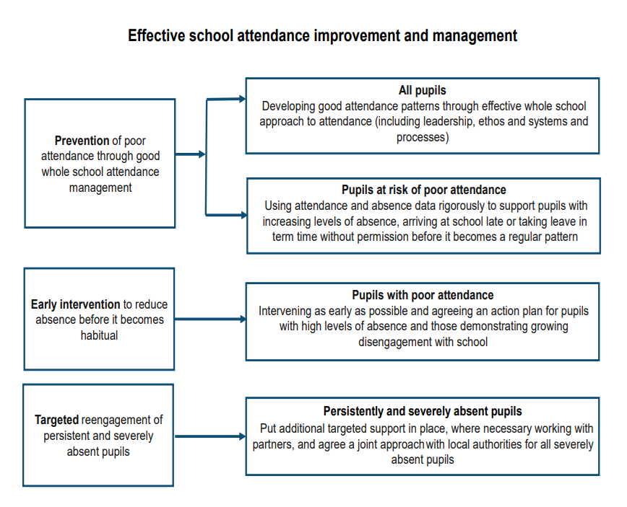

Section 5: Legal Intervention
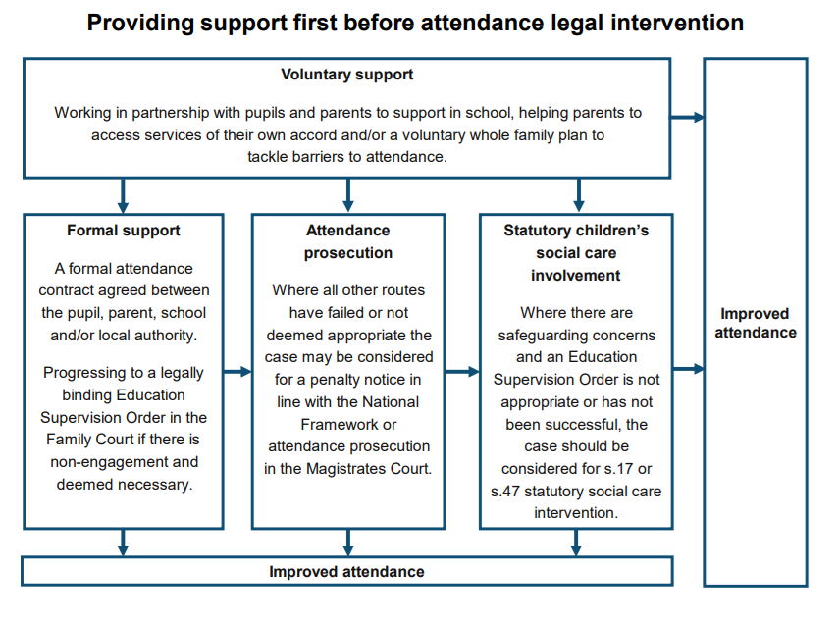
Schools and local authority will to work together and make use of the full range of legal interventions. These are:
- Attendance Contracts
- Education supervision orders
- Attendance prosecution
- Parenting orders
- Penalty notices

SECTION 6: Applications for Leave of Absence
Requests must be made in advance or the absence cannot legally be authorised. All requests must be made at least two weeks in advance to the Schools Attendance Lead by completing the school application form – see Appendix 2. A parent/carer with whom the child resides must make the application. The form must be fully completed and you will receive a written response confirming if the request will be authorised or not – see Appendix 11.

If leave is granted (which will be extremely rare) and you are travelling abroad you will need to supply the school with confirmation of your return flight tickets, such as bringing a copy of the flight tickets into the school office for us to copy.

Unauthorised Absence
If you take your child out of school without the school’s prior authorisation (which is illegal), the absence will be recorded as unauthorised and noted in your child’s school records. Leave of absence can only be authorised by the School Attendance Lead or the Headteacher.

“The threshold is 10 sessions of unauthorised absence in a rolling period of 10 school weeks. A school week means any week in which there is at least one school session. This can be met with any combination of unauthorised absence (e.g. 4 sessions of holiday taken in term time plus 6 sessions of arriving late after the register closes all within 10 school weeks). These sessions can be consecutive (e.g. 10 sessions of holiday in one week) or not (e.g. 6 sessions of unauthorised absence taken in 1 week and 1 per week for the next 4 weeks). The period of 10 school weeks can also span different terms or school years (e.g. 2 sessions of unauthorised absence in the Summer Term and a further 8 within the Autumn Term).” (Working Together to Improve School Attendance, August 2024). At Moulton Primary School children who attend school no less than 10 sessions of the time within a period of 10 weeks, we would define this as irregular attendance.

If you take you take your child out of school for an accumulative total of 5 days or more (10 sessions) (90%) over a period of 10 weeks, the school will deem this as irregular attendance and will consider a referral to the Local authority for consideration of legal action.
This could include:
- a Penalty Notice payable up to £160 fine
- prosecution under s444 (1) Education Act 1996, where if convicted you may be fined up to £1,000
- prosecution under s444 (1) (a) Education Act 1996 where if convicted you may be fined up to £2,500 and/or 3 months’ imprisonment

- There is now a single consistent national threshold for when a penalty notice must be considered of 10 sessions (usually equivalent to 5 school days) for any unauthorised absence within a rolling 10 school week period. The 10-week period may span different terms or school years. For example, 2 sessions of unauthorised absence in the summer term and a further 8 within the autumn term.
- An increase to the rate of a penalty notice from £120 to £160 if not paid within 28 days and £60 to £80 if not paid within 21 days. If a second penalty notice is issued to the same parent for the same child within a rolling 3-year period, the notice will be charged at the higher rate of £160 with no option for this second offence to be discharged at the lower rate of £80.
- A national limit of 2 penalty notices that can be issued to a parent for the same child within a rolling 3-year period, so at the 3rd (or subsequent) offence(s) another tool must be considered (such as prosecution or another attendance legal interventions).

Failure to return to school on the date expected
If there is a reason which delays the child in returning to school, the parent/carer must inform the school immediately. The school will require evidence of this issue and will then decide whether the absence will be authorised. For any travel arrangements outside of the UK, we require proof of return flights, prior to the leave being taken. This may prevent you from receiving authorised absence for your child and being fined if they are unable to return on the date expected. Each case will be assessed individually and medical evidence from abroad will not be accepted routinely as evidence that a child was unable to attend school.

Roll Removal
A child can be removed from roll in either of these circumstances:

- If you take your child on a leave of absence which has been authorised by the school but your child fails to return on the agreed date, any extra time absent from school will be counted as unauthorised. If your child fails to return within ten days of the expected date of return, then the school may remove your child from the school roll and notify the Local Authority accordingly
- Or, if your child has 20 school days continuous unauthorised absence

If a child is removed from roll without information of a new school, the school will inform the Attendance Advice Officer and Local Authority and Child Missing in Education (CME) procedures will be followed.

Other Absence
Other absence from school will be considered on an individual basis and a decision will be made to authorise or unauthorise the absence.

SECTION 7: MONITORING AND REPORTING ATTENDANCE

Attendance is monitored regularly,

- The Admin Team will telephone families whose child is absent on the first day of absence where no phone call is received or no reason has previously been given.
- Teachers must inform the Attendance Lead when they notice patterns of absence.
- Attendance data will be reviewed regularly to establish patterns of irregular attendance. This will include children with incomplete weeks; Monday and Friday absences; lateness; periods of extended absence; periods of un-authorised; and all children with attendance below 90%. This data will be discussed with the Local Authority Schools Attendance Officer, as part of the regular half termly meetings.
- The school and Local Authority Schools Attendance Officer, will discuss the impact of the School’s Attendance Policy, attendance target and the strategies used to promote good attendance annually and the Headteacher will recommend an attendance target to the Governors.

Reporting Attendance

To Parents and Carers
All absences, both authorised and unauthorised, and lateness will be reported to parents and carers three times a year, during the Autumn and Spring Parent/Carer Consultation Meetings and at the end of the academic year in their child’s annual report.

In order to give parents/carers a benchmark to their child’s attendance to other children in the school and nationally the following grades will be used:

100% | Excellent
98% - 99.9% | Very Good
96% - 97.9% | Good
90% - 95.9% | Satisfactory
Under 90% | Unsatisfactory

Parents and carers are able to make an appointment with the Attendance Lead, SLT or Local Authority Schools Attendance Officer, to discuss any concerns they have. (Appendix 3 – Attendance Factsheet)

Parents are given information about whole school attendance in weekly newsletters.

To Local Authority Schools Attendance Support Service
The Attendance Lead provides an attendance print out of 95% and below to assist the Attendance Officer with their work.

To the Department for Education
Three times a year the Business Manager supported by the Attendance Lead completes the Census return as per guidelines.

To the Governing Body
The Headteacher reports on attendance each term.

Promoting and Rewarding Good Attendance
Each week the class in each School Family with the best attendance will receive a certificate.

Improving Poor Attendance
The regular monitoring and analysis of school registers, enables patterns and trends to be identified. See Appendix 4 for school monitoring procedures.

Children who are subject to either a Child Protection or Child in Need Plan (CIN), children who are in public care (LAC), Young Carers and any other vulnerable child’s attendance are prioritised each day for absence phone calls and reporting. This is the responsibility of the Admin Team who will report directly to the Attendance Lead and SLT with any concerns.

96% and below
If attendance drops below 96% the Attendance Lead or Headteacher will inform parents/carers with a letter (Appendix 5) advising them that their child’s attendance/punctuality will be monitored for the next four weeks. Parents are able to meet the Class Teacher, Headteacher, or Attendance Lead to discuss this further.

89% and below
If attendance drops below 89% the child is classed as a ‘Persistent Absentee’. Parents will be invited to a meeting with the Attendance Lead and in some cases a member of the SLT. This meeting will be followed up with a letter (see Appendix 6).

85% and below
If attendance is below 85%, the child continues to be classed as a ‘Persistent Absentee’, at this stage the Local Authority Schools Attendance Officer, may meet with parents/carers. Fixed penalties may be incurred with the possibility of prosecution where no significant improvement is evident.

The aim throughout this process is to ensure all children have the best attendance possible. The school will work in partnership with parents/carers and take into account individual circumstances, applying the process accordingly.

A visit to families at home will be conducted, at any time, where necessary.

Improving Punctuality
Step 1
Once a child has arrived late for school on two occasions within a week a letter will be sent home with the expectation that punctuality will improve (see Appendix 7).

Step 2
If the child continues to be late in the following week the Attendance Lead will make a phone call to parents/carers to inform them of the number of lates their child has incurred and to find out reasons for the poor punctuality.

Step 3
If the child persists in being late the Attendance Lead will arrange a meeting with the child and parent/carer where actions and targets will be set (see Appendix 8).

Policy Implementation
The policy and associated guidance will be discussed with staff and governors.
A copy of registration guidance will be given to supply staff working in the school.
Families will be informed of the attendance procedures via the school website, school induction meetings and newsletters.

The policy will be reviewed in September 2026 or sooner if regulations change.

Appendix 1

ABSENCE PROCEDURES

DAILY FROM DAY 1
Telephone call or parentmail message from parent to explain absence before 9.00am.
School to telephone parent by 10am to establish reason for absence.
NO NO

YES
Reason obtained
YES
Absence recorded with appropriate code.

NO
SLT to make decision made whether a home visit is conducted based on prior knowledge and current attendance.
If no response a note is left requesting parent to contact school. The school may also request a Police Welfare Check.
If child is subject to a CP plan or LAC contact allocated Social Worker and discuss school actions.

Attendance Policy followed.
Child discussed at next Case Review Meeting with SLT where actions are identified.

Appendix 2


Moulton Primary School
Church Hill, Moulton, Northampton
Telephone: 01604 643061
www.moultonprimaryschool.co.uk

CHILD LEAVE of ABSENCE REQUEST FORM
Please complete a form for each child you are requesting absence for. You will receive a copy of this form once your request has been considered for authorisation and a copy will be placed in your child’s file.

Date of Submitting Absence Request: | Name of Child: |  | Child’s Class:
Date of Absence Requested: | From: |  | To (please note this is the date we expect your child to return to school):
Reason for Absence Request: (please note that the headteacher will not authorise any holidays in term time)

Parent/Carer 1 Name and Signature: |  | Parent/Carer 2 Name and Signature:

If there are two Parents/Carers in the family, both need to sign this form.

Please be informed that the school is not permitted to authorise any absence during term time for a holiday.

It is a legal requirement that registered pupils of compulsory school age (5+) attend school regularly and punctually and parents or guardians risk prosecution if they fail in this duty.

A new National Framework for Penalty Notices has been introduced as follows:
- There is now a single consistent national threshold for when a penalty notice must be considered of 10 sessions (usually equivalent to 5 school days) for any unauthorised absence within a rolling 10 school week period. The 10-week period may span different terms or school years. For example, 2 sessions of unauthorised absence in the summer term and a further 8 within the autumn term.
- An increase to the rate of a penalty notice from £120 to £160 if not paid within 28 days and £60 to £80 if not paid within 21 days. If a second penalty notice is issued to the same parent for the same child within a rolling 3-year period, the notice will be charged at the higher rate of £160 with no option for this second offence to be discharged at the lower rate of £80.
- A national limit of 2 penalty notices that can be issued to a parent for the same child within a rolling 3-year period, so at the 3rd (or subsequent) offence(s) another tool must be considered (such as prosecution or another attendance legal interventions).

A copy of the school's attendance policy is available on the website or upon request if you require further information.

School Use Only | Date request for absence received (Date Stamp): |  |  |  | Child’s Attendance:
Unauthorised |  | Authorised |  | Part Authorised | If Part Authorised, How Many Sessions?
Signature: |  |  | Print Name: |  | Date:

Appendix 3

Moulton Primary School
Attendance Information

Remember – Always apply to Miss Jones via the leave of absence request form if you need to request leave during term time.

By law, all children must receive a full time education. As a parent/carer you are responsible for making sure that your child attends school regularly and on time.

What can I do to help my child attend school regularly?

- Ensure your child attends school every day and on time
-If your child is ill, contact the school on the first day of absence by parentmail or phone call (01604 643061)
-Take an interest in your child’s education
-Only take holidays in school holiday time
-Talk to the school if you have concerns

Regular attendance also means
PUNCTUAL attendance.

Arrive on time for your child’s designated start time

All children arriving 15 minutes after their designated start time will receive a late mark (L code on the register)

Children arriving after 09:30am receive a “U” code on the register – unauthorised late absence

Please remember to pick your child/children up on time.

Illness

-Children must not attend school if they have any infectious illnesses (please take advice from your GP) e.g. Chicken Pox, Measles, German Measles, mumps etc.
-Sickness and Diarrhoea (48 hours)
-Flu (diagnosed by GP) etc.

The school will always contact you if your child is unwell – always try to send your child to school even if they feel a little “under the weather” e.g. runny nose, tummy ache, headache etc.

If you are unsure if your child can attend school, please contact the school office for further information and advice 01604 643061

Unacceptable reasons for absence:

Shopping
Birthday treats and trips
Looking after others at home
Non-urgent medical or dental appointment
Your car breaking down
Picking up or taking relatives to the airport
Family Holidays etc.
These absences will be marked as unauthorised

Appendix 4

Moulton Primary School’s
Attendance Monitoring Procedures

At Moulton Primary School, we strongly believe that outstanding attendance is vital to ensuring that every child achieves their potential. Therefore we strive to improve constantly and achieve an attendance of 96% or above.

100-96% | •Constant monitoring of attendance by SLT/Attendance Lead  •Certificates issued termly to celebrate 96%+ attendance  •Half termly rewards for a class in each year group with the highest attendance
95-90% | •Constant monitoring of attendance by SLT/Attendance Lead  •Regular monitoring by Independent Attendance Welfare Advisor,  •Child encouraged to improve attendance by Class Teacher/Team Leader  •Letter sent to parents/carers to inform them that attendance has dropped below 96%  •Support offered to parents with Attendance Lead
89-85%  Persistent Absentee | •Daily monitoring of attendance by school and Independent Attendance Welfare Advisor,  •Parents/carers invited to meet with Attendance Lead and SLT  •Weekly records kept and parents.carers informed if attendance improves or drops  •Home visit from school if appropriate
84% & below  Persistent Absentee | • Local Authority Schools Attendance Officer will monitor attendance  • Local Authority Schools Attendance Officer may request for medical evidence to be provided in order for absences to be authorised  •Fixed penalties for those parents/carers that do not demonstrate significant improvement

Appendix 5 (Letter 1)

Church Hill  Moulton  Northampton NN3 7SW  Telephone: 01604 643061  e-mail: office@moultonprimaryschool.co.uk  Headteacher: Miss Jones |  | 

Date:

Dear Parent/Carer

Child’s Name:………………………………………………………………

This letter is to inform you that your child’s attendance has fallen below 96%, it is currently xxxxxxx%.

96% and above is considered good attendance, this letter is just to make you aware of your child’s current attendance.

We know that illness happens occasionally, this cannot be helped and your child will need to stay at home to get better. There are also those days where it is not easy to decide if your child should be in school or not. We are happy for you to send your child in on these days, as we will always contact parents if it is apparent that they are not well during the day.

If you would like to discuss any issues you are experiencing which may be impacting your child’s attendance, please contact the school office and make an appointment to see either your child’s class teacher or Mrs Johnson.

We will continue to monitor your child’s attendance and look forward to seeing the improvement.

Yours sincerely

Mrs Johnson
Assistant Headteacher
Attendance Lead

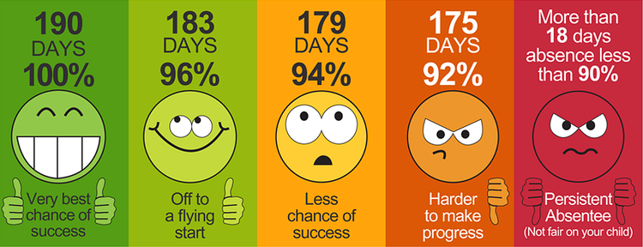

 |  |  |  |  |  | 

Appendix 6 (Letter 2)

Church Hill
Moulton
Northampton NN3 7SW

Telephone: 01604 643061
e-mail: office@moultonprimaryschool.co.uk

Headteacher: Miss Jones

Date:

Dear Parent/Carer

Child’s Name:

As you will be aware from our previous letter dated xxxxxx, we have been monitoring NAME’s attendance to ensure that is has been improving significantly, rising towards a target of 96% or above.

When reviewing NAME’s attendance between xxxxxxxx and xxxxxxxx their attendance was xxxxx%. This means that NAME’s attendance has not improved and remains below 96%. For this reason NAME will remain on a further four weeks of monitoring from today’s date and if after this point their attendance does not improve to 96% or above, we will refer your case on to the Local Authority Schools Attendance Officer.

Consistently good attendance in school is crucial to ensuring that every child makes progress and learns well. Schools and Local Authorities have a duty to ensure that parents/carers undertake their legal responsibility of ensuring their children attend school at least 96% of the time.

If you are experiencing any difficulties, we are here to support. Please make an appointment to speak to Mrs Johnson and we will work together to improve your child’s attendance.

Yours sincerely

Mrs Johnson
Attendance Lead

Appendix 7 (Letter 3)
Church Hill
Moulton
Northampton NN3 7SW

Telephone: 01604 643061
e-mail: office@moultonprimaryschool.co.uk

Headteacher: Miss Jones

Date:

Dear Parent/Carer,

Further to my pervious letter dated xxxxx, in regards to NAME’S attendance, I must you inform you that there has been insufficient improvements. I have now referred your case to our Local Authority Schools Attendance Officer, who will make contact with you directly to arrange a time to meet with you at the school.

During this time all absences will be unauthorised unless you provide medical evidence, This can be in the form of a medical card from the doctors or dentist (emergency appointments only).

Yours sincerely

Mrs Johnson
Attendance Lead

Church Hill  Moulton  Northampton NN3 7SW  Telephone: 01604 643061  e-mail: office@moultonprimaryschool.co.uk  Headteacher: Miss Jones | Appendix 8 (Letter 4)

Date:

Dear Parents/Carers,

We would like to congratulate you and NAME, for making the improvements necessary to meet the attendance target of 96% or above.

NAME’s attendance has now reached xxx%

We have been really impressed by your hard work and hope that we will continue to see the impact of this in the future.

Well done to you all ☺.

Yours sincerely

Mrs Johnson
Attendance Lead

Appendix 9 (Letter 5)

Church Hill
Moulton
Northampton NN3 7SW

Telephone: 01604 643061
e-mail: office@moultonprimaryschool.co.uk

Headteacher: Miss Jones

Date:

Dear

Child’s Name:

Number of days late: | From: | To:

This letter is to share our concerns with you about your child’s punctuality.

It is important that children arrive at school on time so that they are ready to start lessons promptly.

When your child arrives at school late, the lessons have already started. As well as disrupting your child’s progress, it also disrupts the learning of other children, as the teacher has to stop the lesson in order to catch your child up.

Failure to improve punctuality will mean that a meeting will be arranged with you to discuss this further.

Please do not hesitate to contact the school if there is anything we can do to support you with your child’s punctuality.

Yours sincerely

Mrs Johnson
Attendance Lead

Appendix 10

Church Hill
Moulton
Northampton NN3 7SW

Telephone: 01604 643061
e-mail: office@moultonprimaryschool.co.uk

Headteacher: Miss Jones

Date:

Dear

Child’s Name:

Number of days late: | From: | To:

Thank you for attending the meeting today to discuss your child’s punctuality.

As discussed it is so important that NAME arrives at school on time every day so that they are ready to start their lessons promptly.

We will continue to monitor punctuality and hope to see a consistent improvement.

If for any reason there is no improvement, the school will refer your case to the Local Authority Schools Attendance Officer, for further action and support.

Yours sincerely

Mrs Johnson
Attendance Lead

Appendix 11

Church Hill
Moulton
Northampton NN3 7SW

Telephone: 01604 643061
e-mail: office@moultonprimaryschool.co.uk

Headteacher: Miss Jones

Dear xxx

I have had been reviewing the attendance of xxxx and need to inform you that the absence that will be taken between xxxx and the xxxxx will be unauthorised.
Please be informed that the school is not permitted to authorise any absence during term time for a holiday.

It is a legal requirement that registered pupils of compulsory school age (5+) attend school regularly and punctually and parents or guardians risk prosecution if they fail in this duty a new National Framework for Penalty Notices has been introduced as follows:
- There is now a single consistent national threshold for when a penalty notice must be considered of 10 sessions (usually equivalent to 5 school days) for any unauthorised absence within a rolling 10 school week period. The 10 week period may span different terms or school years. For example, 2 sessions of unauthorised absence in the summer term and a further 8 within the autumn term.
- An increase to the rate of a penalty notice from £120 to £160 if not paid within 28 days and £60 to £80 if not paid within 21 days. If a second penalty notice is issued to the same parent for the same child within a rolling 3 year period, the notice will be charged at the higher rate of £160 with no option for this second offence to be discharged at the lower rate of £80.
- A national limit of 2 penalty notices that can be issued to a parent for the same child within a rolling 3- year period, so at the 3rd (or subsequent) offence (s) another tool must be considered (such as prosecution or another attendance legal interventions).
Please find attached a copy of the absence form.
Yours sincerely,

Mrs Johnson
Assistant Headteacher

